

Activity Standards
Curve Runner

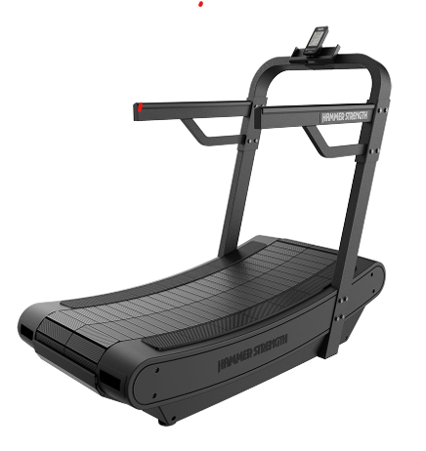

Area of Body Worked

Ankles and Soles

Calves

Thighs: quadriceps and hamstrings

Glutes More activation will occur higher on the incline
- Back
- Chest
- Shoulders
- Arms
- Core
- Cardiovascular system.

Clothing

Participants must wear appropriate indoor clothing, with special attention to footwear. For example, running trainers, joggers, shorts, t-shirt, vest. No loose jewellery. Long hair tied back.

Activity Site / Area
Zone 1 Fitness Suite

Pre-Session Checks
- Check the treadmill for any defects or damage.
- Check the treadmill is clean and free from any obstructions.
- Check other site users are not at risk while participating.

Do’s & Don’ts
- Do warm up prior to embarking on a session.
- Don’t exceed the maximum weight limit (350lbs/159kg)
- Do use the handrails for mounting, dismounting and balance.
- Do position yourself on the striding let facing the console.
- Don’t increase the incline/speed too quickly.
- Don’t hold onto the handrails/console while exercising as it will lead to inefficient running form, potentially leading to neck, shoulder and back pain.
- Don’t step on and off while the treadmill belt is moving.
- Do practice proper upper body form by keeping your arms at a 90 degree angle.
- Do stay upright and look up/straight ahead as this is the safest way to run.
- Do pay attention to your stride and work towards improving your stride count.
- Do hydrate, particularly if running for over 20 minutes. This will help to maximise performance.
- Do cool down. Slowly winding down will allow your heart rate and blood pressure to fall gradually. Try not to end your cool down until heart rate goes below 100bpm. Ideally follow with post run stretches.

Beginner Work Out

3-2-1 Session

Warm-up
- 5 minutes at easy pace
Main set
- 3 minutes fast
- 2 minutes of recovery jogging
- 2 minutes fast
- 2 minutes of recovery jogging
- 1 minutes fast
- 2 minutes of recovery jogging
  - Repeat x 1
Cooldown
- 5 minutes at easy pace

